EX NO:7
DATE: SERVLET PROGRAM USING COOKIES

AIM:
To write a servlet program using cookies.

PROGRAM:
Cookies.jsp:

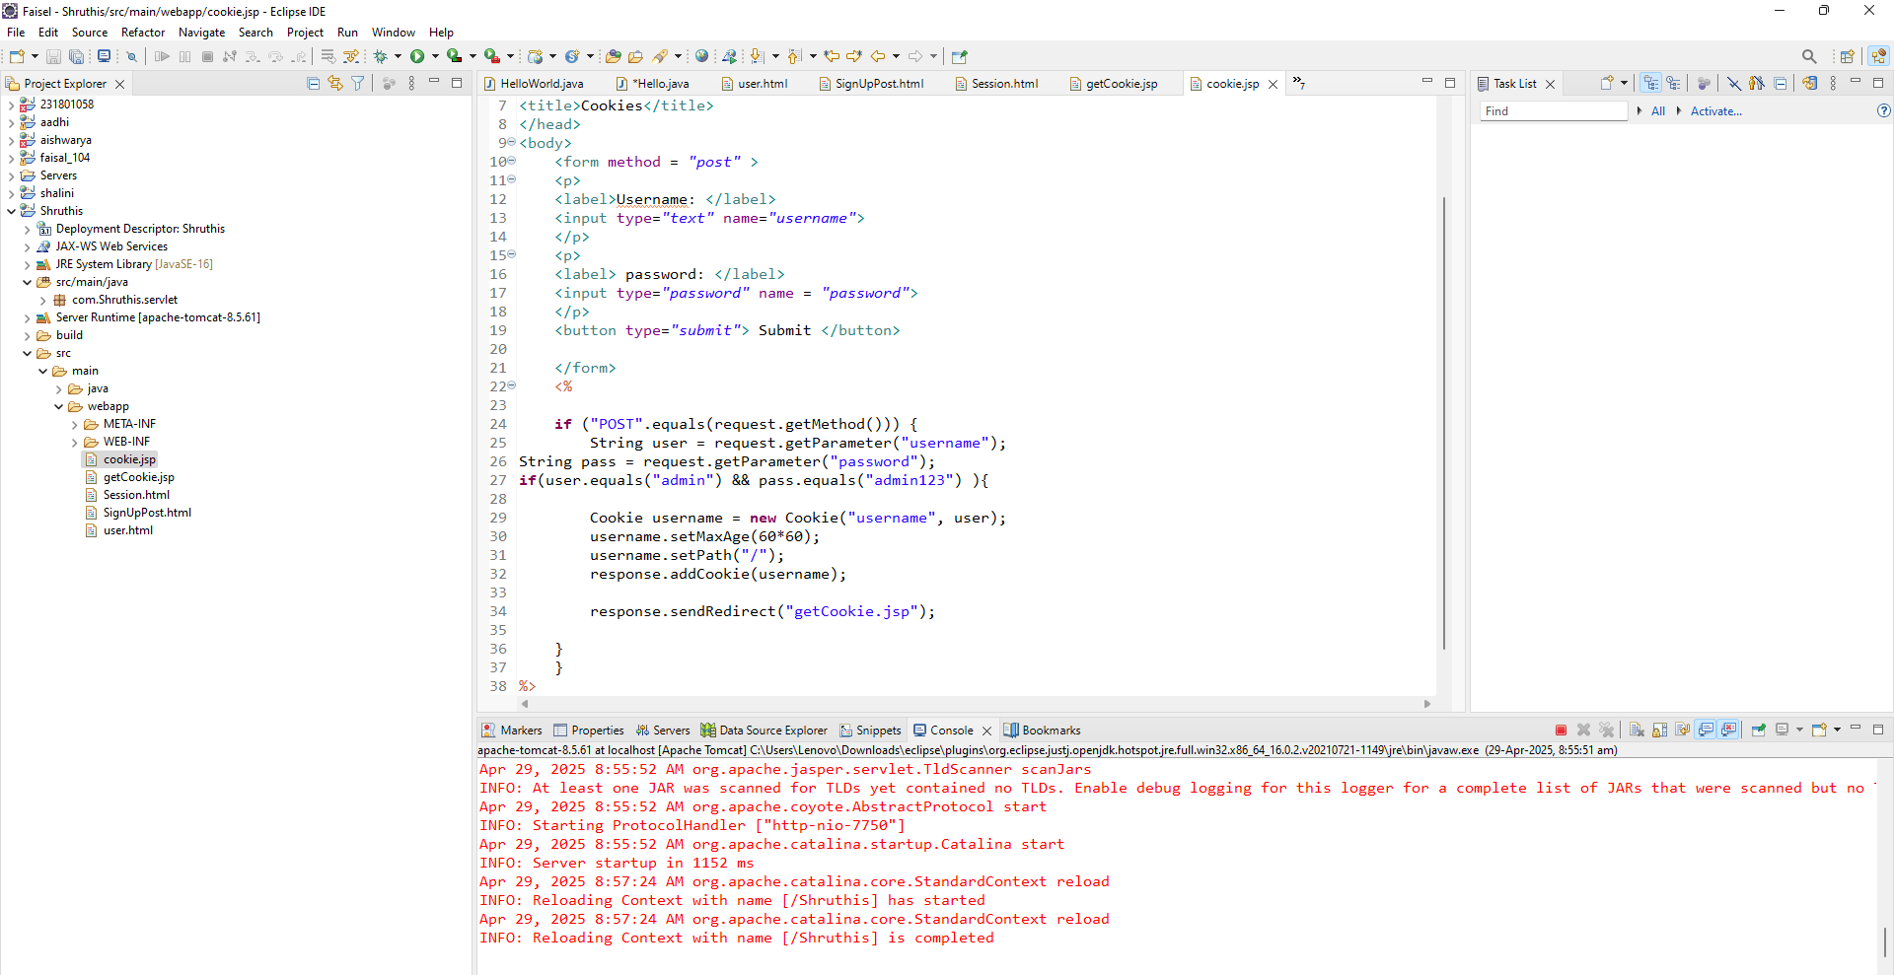

Getcookie.jsp:

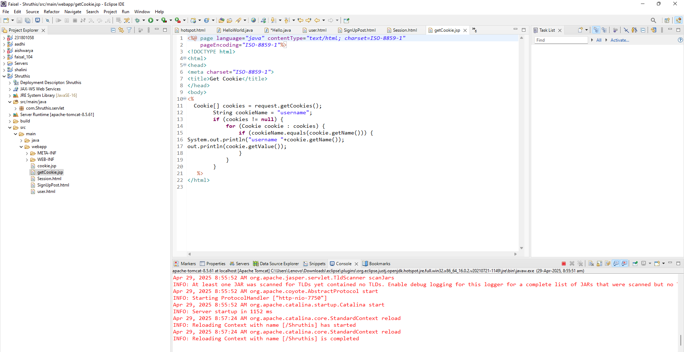

Output:

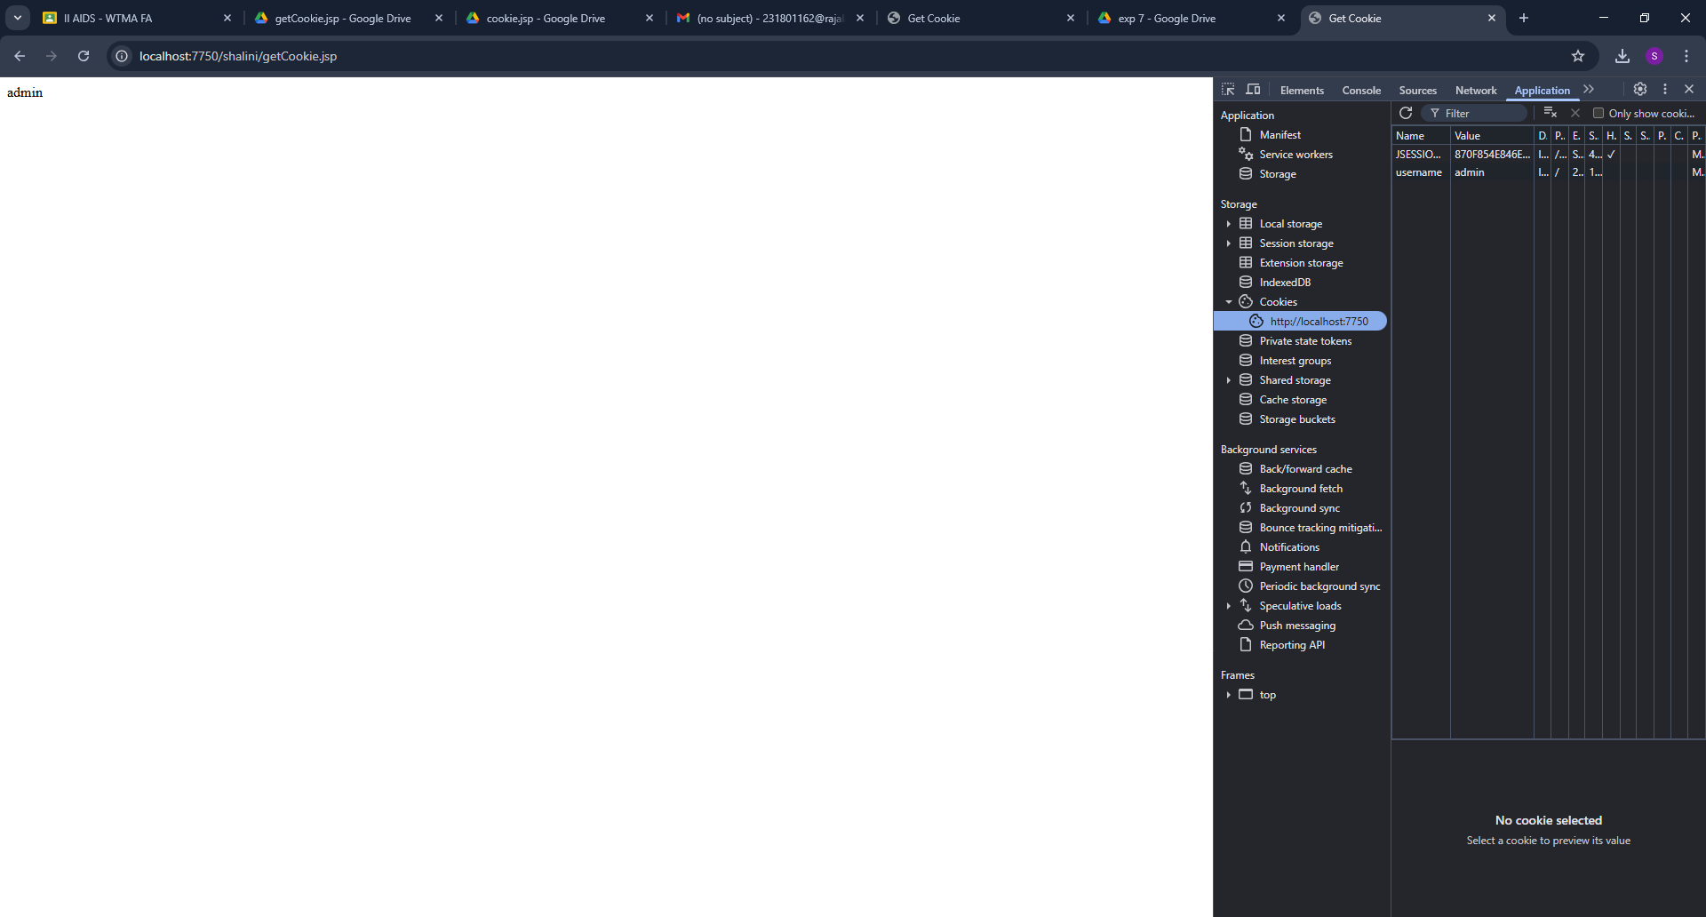
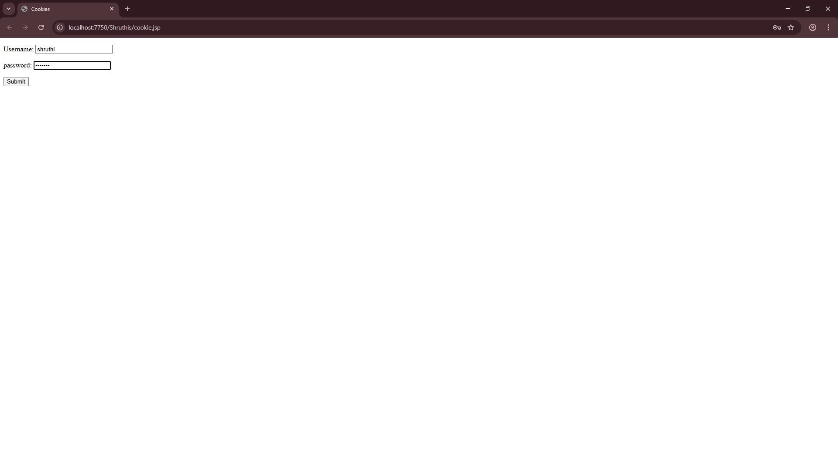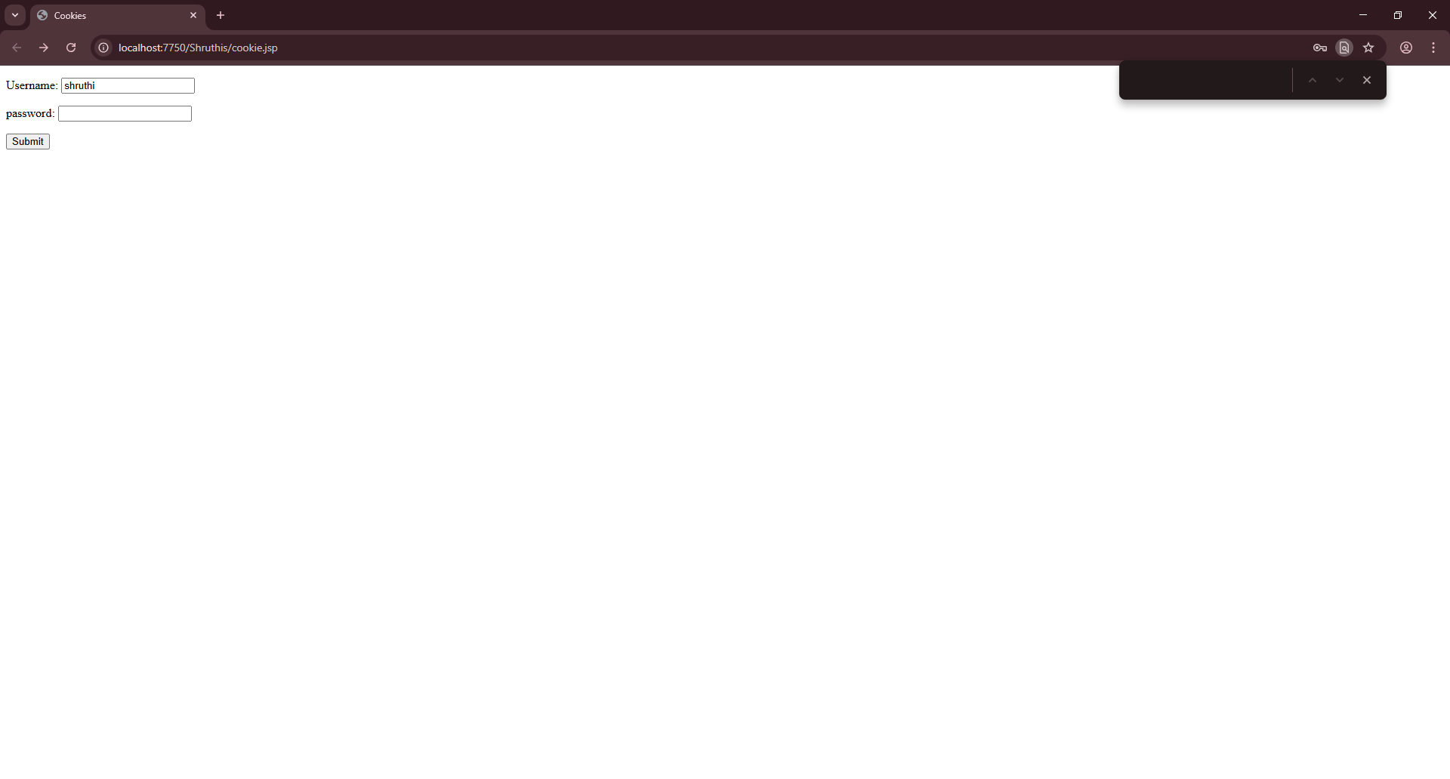

Result:
The program is executed successfully.

